Temporal Cohesion

📌 Definition:
# Source: AI Source: Provided by: [Data Path: Persons Table -> ID Column: 1, Name_En Column: Motasem Essam] -> From: [Chatgpt (GPT‑5 Mini)] on [12/9/2025]
Temporal Cohesion occurs when elements of a class/module are grouped because they are executed at the same time, such as during initialization or startup, regardless of whether they share data or purpose.

🧠 Simple idea:
# Source: AI Source: Provided by: [Data Path: Persons Table -> ID Column: 1, Name_En Column: Motasem Essam] -> From: [Chatgpt (GPT‑5 Mini)] on [12/9/2025]
“Grouped by timing, not by function” ⏱️

🔍 Key characteristics:
# Source: AI Source: Provided by: [Data Path: Persons Table -> ID Column: 1, Name_En Column: Motasem Essam] -> From: [Chatgpt (GPT‑5 Mini)] on [12/9/2025]
- Elements are related by when they run
- 🟡 Moderate to low cohesion (weaker than procedural)
- ❌ May combine unrelated tasks
- ⚙️ Common in initialization routines or setup methods

📊 Example:
# Source: AI Source: Provided by: [Data Path: Persons Table -> ID Column: 1, Name_En Column: Motasem Essam] -> From: [Chatgpt (GPT‑5 Mini)] on [12/9/2025]
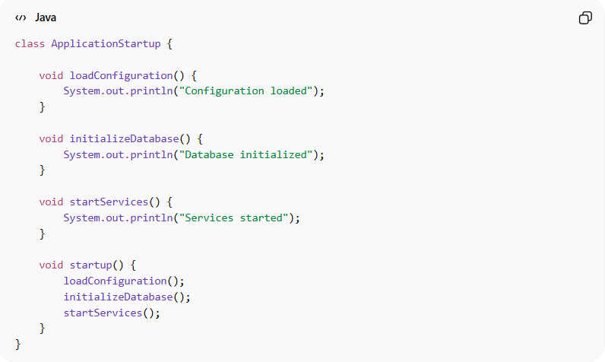
class ApplicationStartup {

void loadConfiguration() {
System.out.println("Configuration loaded");
}

void initializeDatabase() {
System.out.println("Database initialized");
}

void startServices() {
System.out.println("Services started");
}

void startup() {
loadConfiguration();
initializeDatabase();
startServices();
}
}
- ✅ All methods run at application startup
- ❌ Methods are not functionally related beyond timing → temporal cohesion

🛡️ Avoiding Temporal Cohesion Example:
# Source: AI Source: Provided by: [Data Path: Persons Table -> ID Column: 1, Name_En Column: Motasem Essam] -> From: [Chatgpt (GPT‑5 Mini)] on [12/9/2025]
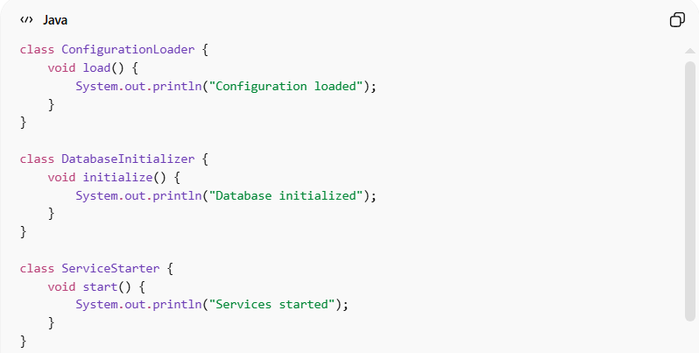
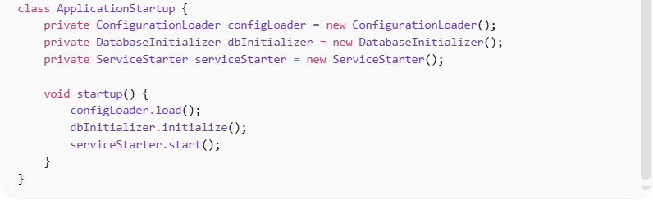
class ConfigurationLoader {
void load() {
System.out.println("Configuration loaded");
}
}

class DatabaseInitializer {
void initialize() {
System.out.println("Database initialized");
}
}

class ServiceStarter {
void start() {
System.out.println("Services started");
}
}

class ApplicationStartup {
private ConfigurationLoader configLoader = new ConfigurationLoader();
private DatabaseInitializer dbInitializer = new DatabaseInitializer();
private ServiceStarter serviceStarter = new ServiceStarter();

void startup() {
configLoader.load();
dbInitializer.initialize();
serviceStarter.start();
}
}
Usage:
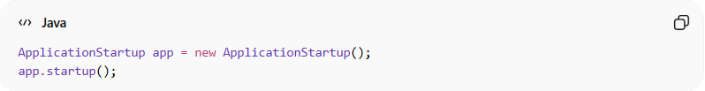
ApplicationStartup app = new ApplicationStartup();
app.startup();
✅ Key improvements:
- 🧩 Each class handles one type of initialization
- 🔄 Startup steps are organized but independent
- ⚙️ Easier to modify or replace individual startup components
- 🔗 Reduced temporal cohesion in one monolithic class

⚙️ Best Practice:
# Source: AI Source: Provided by: [Data Path: Persons Table -> ID Column: 1, Name_En Column: Motasem Essam] -> From: [Chatgpt (GPT‑5 Mini)] on [12/9/2025]
- Group only truly related startup/init tasks
- Consider separating unrelated tasks into dedicated classes
- Maintain clarity of purpose even during startup
- Prefer functional or communicational cohesion when possible

